

**Faculty of engineering - Shoubra**

**Benha University**

**Research Article / Research Project / Literature Review**

in fulfillment of the requirements of

|  |  |
| --- | --- |
| **Department** | **Engineering Mathematics and Physics** |
| **Division** | **-----------------** |
| **Academic Year** | **2019-2020 Preparatory** |
| **Course name** | **Computer** |
| **Course code** | **EMP012** |

**Title: -**

**Programing languages:**

|  |  |  |
| --- | --- | --- |
| Name | Edu mail | B.N |
| Ahmed Nasr Ahmed |  |  |

**Approved by:**

|  |  |
| --- | --- |
| Examiners committee | Signature |
|  |  |
|  |  |
|  |  |
|  |  |
|  |  |

**Application brief:**

* I chose a topic "programming languages" to create website pages about it.

**Why I chose this topic?**

It is a very important topic as programming languages enter in all fields such as:

health and industry as it is considered the bedrock of many other different fields

besides that the development of devices in all institutions has now relied heavily on

the programming language especially hospitals and industrial places and others.

**Applications of programming languages:**

1. Java: represents the thinking mind in operating and managing smart applications and devices.
2. C++: it works in designing complex applications and interfaces, and it is the only language that works with complex data.
3. C: it works in development the Unix operating system.
4. Php: it used in developing web applications and can be used to create programs completely.

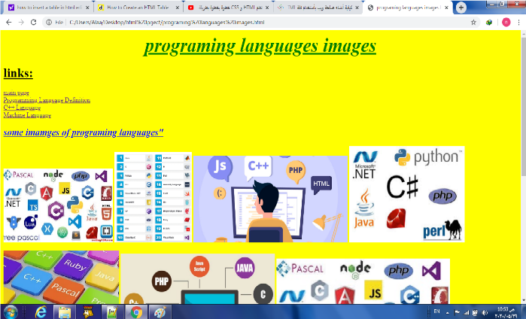**Screen shots of website**:

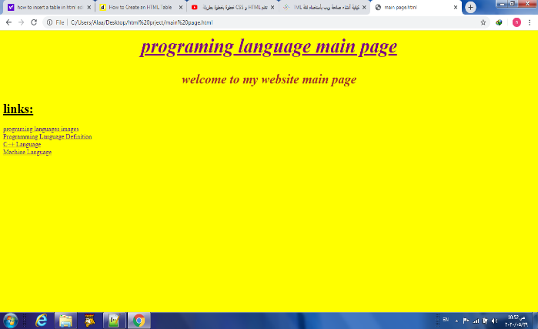

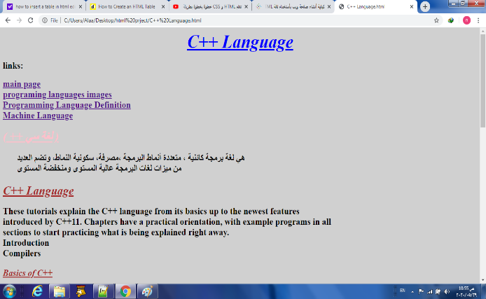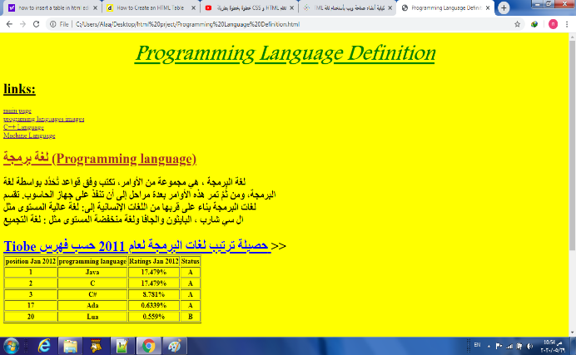

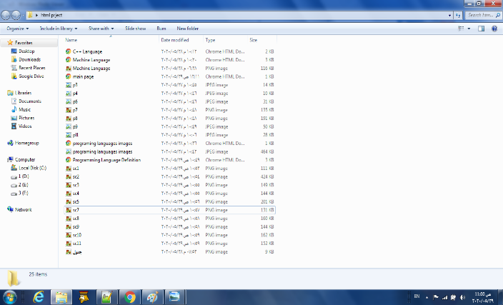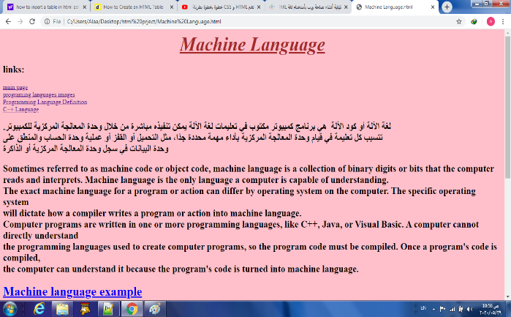

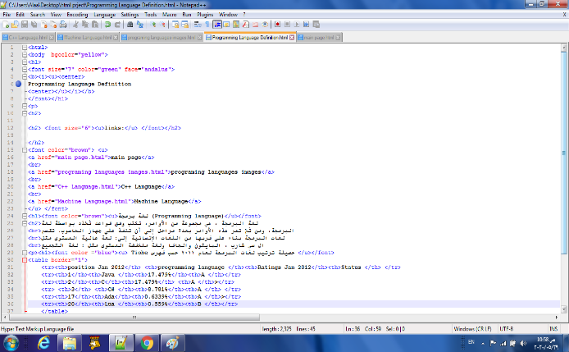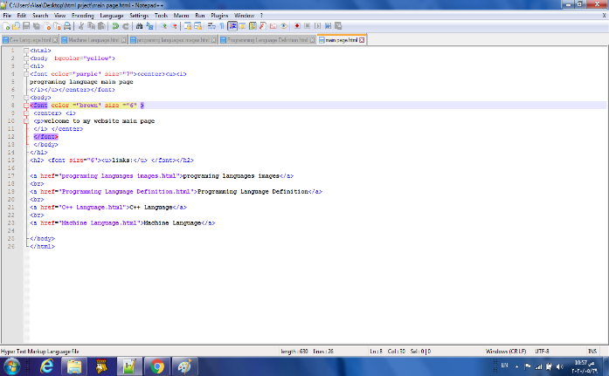**Screen shots of codes**

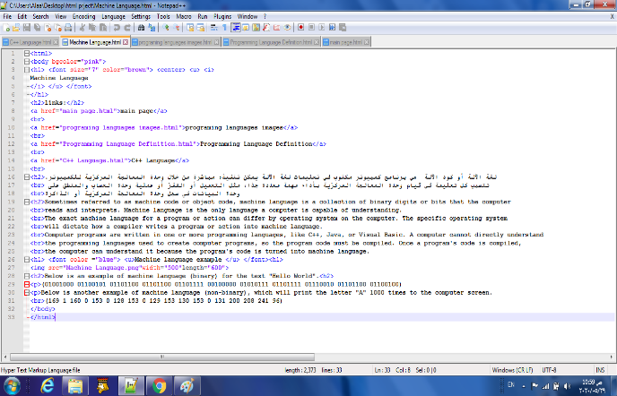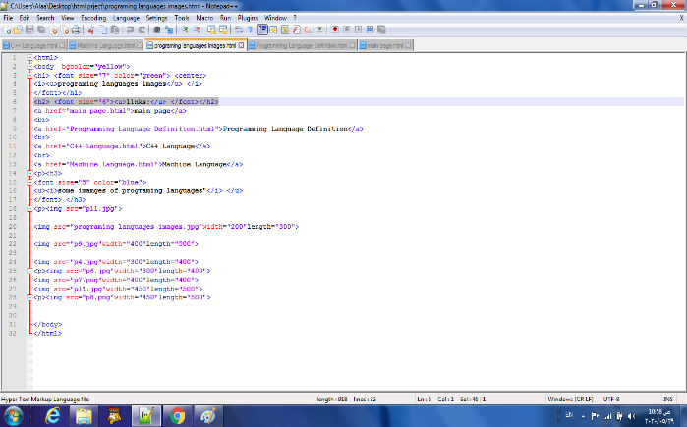

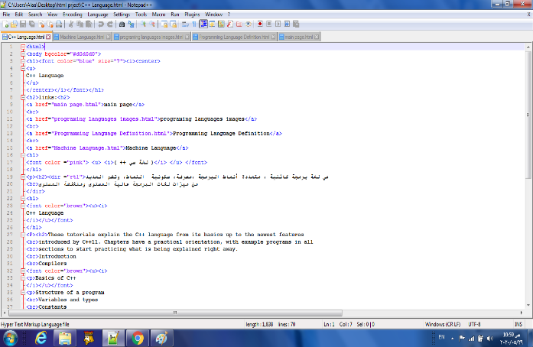

**https://github.com/ahmednasrahmed/ace001.git**

**References**

1. [<https://en.wikipedia.org/wiki/Programming_language>.](https://en.wikipedia.org/wiki/Programming_language)
2. <https://techterms.com/definition/programming_language>
3. <https://www.google.com/search?q=%D8%B5%D9%88%D8%B1+%D9%84%D8%A8%D8%B9%D8%B6+%D9%84%D8%BA%D8%A7%D8%AA+%D8%A7%D9%84%D8%A8%D8%B1%D9%85%D8%AC%D8%A9&oq=%D8%B5%D9%88%D8%B1+%D9%84%D8%A8%D8%B9%D8%B6+%D9%84%D8%BA%D8%A7%D8%AA+%D8%A7%D9%84%D8%A8%D8%B1%D9%85%D8%AC%D8%A9&aqs=chrome.0.69i59.5048j0j7&sourceid=chrome&ie=UTF-8>
4. <http://www.cplusplus.com/doc/tutorial/>